While it is possible to mangage typographic needs with the foundry tools provided via the font- rendering package-triad, one would be hard-pressed to say that the following is “fun”, or even truly manageable coding:

library(systemfonts)

register_variant(

name = "some-unique-prefix Inter some-style-01", weight = "normal",

features = font_feature(

poss = 1, ibly = 1, many = 1,

four = 1, char = 1, open = 1,

type = 1, code = 1, spec = 1

)

)

# remember that name

register_variant(

name = "some-unique-prefix Inter some-style-02", weight = "normal",

features = font_feature(

poss = 1, ibly = 1, many = 1,

four = 1, char = 1, open = 1,

type = 1, code = 1, spec = 1

)

)

# remember that name

# add a dozen more lines ... ggplot() +

geom_text(family = "oops-i-just-misspelled-the-family-name-*again*",

...)

We’ve been given the power to level up our chart typography, but it’s sort of where literal typesetters (the ones who put blocks of type into a press) were and we can totally make our lives easier and charts prettier with the help of a new package — {hrbragg}

— which is somewhat of a bridge between {ragg}, {systemfonts}, {textshaping} and a surprisingly popular package of mine: {hrbrthemes}. {hrbragg} is separate from

{hrbrthemes} since this new typographic ecosystem is fairly restricted to {ragg} graphics devices (*for the moment*, as Thomas alluded the other day), and the new themes provided in {hrbragg} are a bit of a level-up from those in its sibling package.

# Feature Management

At the heart of {systemfonts} lies the ability to tweak font features and bend them to your will. But, what does calt mean? And, what is this tnum fellow you’ll be seeing a great deal

of in R-land over the coming months? While one *could* leave the comfort of RStudio, VS Code, or vim to visit one of the reference links in Thomas’ package or {hrbragg}, I’ve included the most recent copy of tag-code<->full-tag-name<->short-tab-description in {hrbragg} as a usable data frame so you can treat it like the data it is!

library(systemfonts) # access to and tweaking OTFs! library(textshaping) # lets us treat type as data

library(ragg) # because it'll be lonely w/o the other two library(hrbragg)

library(tidyverse) # nice printing, {ggplot2}, and b/c we'll do some font data wrangling

data("feature_dict")

feature_dict

## # A tibble: 122 x 3

## tag long_name description ##

## 1 aalt Access All Alternates Special feature: used to present user with choice all alternate forms of the character

## 2 abvf Above-base Forms Replaces the above-base part of a vowel sign. For Khmer and similar scripts.

## 3 abvm Above-base Mark Positioning Positions a mark glyph above a base glyph.

## 4 abvs Above-base Substitutions Ligates a consonant with an above-mark.

## 5 afrc Alternative Fractions Converts figures separated by slash with alternative stacked fraction form

## 6 akhn Akhand Hindi for unbreakable. Ligates consonant+halant+consonant, usually only for k-ss and j-ny combinations.

## 7 blwf Below-base Forms Replaces halant+consonant combination with a subscript form.

## 8 blwm Below-base Mark Positioning Positions a mark glyph below a base glyph

## 9 blws Below-base Substitutions Ligates a consonant with a below-mark.

## 10 c2pc Capitals to Petite Caps Substitutes capital letters with petite caps

## # … with 112 more rows

You can also use help("opentype_typographic_features") to see an R help page with the same information. That page also has links external resource, one of which is a detailed manual of each feature with use-cases (in the event even the short-description is not as helpful as it could be).

Before one can think about using the bare-metal register_variant(..., font_feature(...)) duo, one has to know what features a particular type family supports. We can retrieve the feature codes with textshaping::get_font_features() and look them up in this data frame to get an at-a-glance view:

# old school subsetting ftw! feature_dict[feature_dict$tag %in% textshaping::get_font_ features("Inter")[[1]],]

## # A tibble: 19 x 3

## tag long_name description ##

## 1 aalt Access All Alternates Special feature: used to present user with choice all alternate forms of the character

## 2 calt Contextual Alternates Applies a second substitution feature based on a match of a character pattern within a context of surrounding patterns

## 3 case Case Sensitive Forms Replace characters, especially punctuation, with forms better suited for all-capital text, cf. titl ## 4 ccmp Glyph Composition/Decompos… Either calls a ligature replacement on a sequence of characters or replaces a character with a sequence of glyphs. Provides…

## 5 cpsp Capital Spacing Adjusts spacing between letters in all-capitals text

## 6 dlig Discretionary Ligatures Ligatures to be applied at the user's discretion

## 7 dnom Denominator Converts to appropriate fraction denominator form, invoked by frac

## 8 frac Fractions Converts figures separated by slash with diagonal fraction

## 9 kern Kerning Fine horizontal positioning of one glyph to the next, based on the shapes of the glyphs

## 10 locl Localized Forms Substitutes character with the preferred form based on script language

## 11 mark Mark Positioning Fine positioning of a mark glyph to a base character

## 12 numr Numerator Converts to appropriate fraction numerator form, invoked by frac

## 13 ordn Ordinals Replaces characters with ordinal forms for use after numbers

## 14 pnum Proportional Figures Replaces numerals with glyphs of proportional width, often also onum

## 15 salt Stylistic Alternates Either replaces with, or displays list of, stylistic alternatives for a character

## 16 subs Subscript Replaces character with subscript version, cf. numr

## 17 sups Superscript Replaces character with superscript version, cf. dnom

## 18 tnum Tabular Figures Replaces numerals with glyphs of uniform width, often also lnum

## 19 zero Slashed Zero Replaces 0 figure with slashed 0

Most of those will not be super-useful (yet) but there are three key features that I believe one needs when picking a font for a chart:

One of the *ligs (because ligatures.) are so gosh darn cool, pretty, and useful)

tnum for tabular numbers (essential in axis value display, and more)

kern for sweet, sweet letterspacing, or *kerning*

Since I’ve just made up a rule, let’s see how many fonts I have that support said rule:

(fam <- unique(system_fonts()[["family"]])) %>% get_font_features() %>%

set_names(fam) %>% keep(~sum(c(

any(grepl("kern", .)),

any(grepl("tnum", .)),

any(grepl(".lig|liga", .))

)) == 3

) %>%

names() %>% sort()

## [1] "Barlow" "Goldman Sans" "Goldman Sans Condensed" "Grantha Sangam MN"

## [5] "Inter" "Kohinoor Devanagari" "Mukta Mahee" "Museo Slab"

## [9] "Neufile Grotesk" "Roboto" "Roboto Black" "Roboto Condensed"

## [13] "Roboto Light" "Roboto Medium" "Roboto Thin" "Tamil Sangam MN"

## [17] "Trattatello"

I do have more, but they’re on a different Mac .

{hrbragg} comes with Inter, Goldman Sans, and Roboto Condensed, so let’s explore one of them — Inter — and see how we might be able to make it useful but not tedious. The supported features of Inter are above and here are the family members:

system_fonts() %>% filter(family == "Inter") %>%

select(name, family, style, weight, width, italic, monospace) ## A tibble: 18 x 7

## name family style weight width italic monospace

##

## 1 Inter-ExtraLight Inter Extra Light light normal FALSE FALSE

## 2 Inter-MediumItalic Inter Medium Italic medium normal TRUE FALSE

## 3 Inter-ExtraLightItalic Inter Extra Light Italic light normal TRUE FALSE

## 4 Inter-Bold Inter Bold bold normal FALSE FALSE

## 5 Inter-ThinItalic Inter Thin Italic ultralight normal TRUE FALSE

## 6 Inter-SemiBold Inter Semi Bold semibold normal FALSE FALSE

## 7 Inter-BoldItalic Inter Bold Italic bold normal TRUE FALSE

## 8 Inter-Italic Inter Italic normal

|  |  |  |  |
| --- | --- | --- | --- |
| normal TRUE FALSE  ## 9 Inter-Medium | Inter | Medium | medium |
| normal FALSE FALSE |  |  |  |
| ## 10 Inter-BlackItalic | Inter | Black Italic | heavy |
| normal TRUE FALSE |  |  |  |
| ## 11 Inter-Light | Inter | Light | normal |
| normal FALSE FALSE |  |  |  |
| ## 12 Inter-SemiBoldItalic | Inter | Semi Bold Italic | semibold |
| normal TRUE FALSE |  |  |  |
| ## 13 Inter-Regular | Inter | Regular | normal |
| normal FALSE FALSE |  |  |  |
| ## 14 Inter-ExtraBoldItalic | Inter | Extra Bold Italic | ultrabold |
| normal TRUE FALSE |  |  |  |
| ## 15 Inter-LightItalic | Inter | Light Italic | normal |
| normal TRUE FALSE |  |  |  |
| ## 16 Inter-Thin | Inter | Thin | ultralight |
| normal FALSE FALSE |  |  |  |
| ## 17 Inter-ExtraBold | Inter | Extra Bold | ultrabold |
| normal FALSE FALSE |  |  |  |
| ## 18 Inter-Black | Inter | Black | heavy |
| normal FALSE FALSE |  |  |  |

Nobody. I mean, *nobody* wants to type eighteen+ font variant registration statements, which is why {hrbragg} comes with reconfigure_font(). Just give it the family name, the features you want supported, and it will take care of the tedium for you:

reconfigure_font(

prefix = "hrbragg-pkg", family = "Inter",

width = "normal",

ligatures = "discretionary", calt = 1, tnum = 1, case = 1,

dlig = 1, ss01 = 1, kern = 1,

zero = 0, salt = 0

) -> customized_inter

# I'll have a proper print method for this soon str(customized_inter, 1)

|  |  |  |  |  |  |  |  |
| --- | --- | --- | --- | --- | --- | --- | --- |
| ## | List of 17 | | | | | | |
| ## | $ | ultralight_italic: | chr | "clever-prefix | Inter | Thin I | talic" |
| ## | $ | ultralight : | chr | "clever-prefix | Inter | Thin" |  |
| ## | $ | light : | chr | "clever-prefix | Inter | Extra | Light" |
| ## | $ | light_italic : | chr | "clever-prefix | Inter | Extra | Light Italic" |
| ## | $ | normal_italic : | chr | "clever-prefix | Inter | Light | Italic" |
| ## | $ | normal_light : | chr | "clever-prefix | Inter | Light" |  |
| ## | $ | normal : | chr | "clever-prefix | Inter | Regula | r" |
| ## | $ | medium_italic : | chr | "clever-prefix | Inter | Medium | Italic" |
| ## | $ | medium : | chr | "clever-prefix | Inter | Medium | " |
| ## | $ | semibold : | chr | "clever-prefix | Inter | Semi B | old" |
| ## | $ | semibold_italic : | chr | "clever-prefix | Inter | Semi B | old Italic" |
| ## | $ | bold : | chr | "clever-prefix | Inter | Bold" |  |

## $ bold_italic : chr "clever-prefix Inter Bold Italic"

## $ ultrabold_italic : chr "clever-prefix Inter Extra Bold Italic" ## $ ultrabold : chr "clever-prefix Inter Extra Bold"

## $ heavy_italic : chr "clever-prefix Inter Black Italic" ## $ heavy : chr "clever-prefix Inter Black"

## - attr(*, "family")= chr "Inter"

The reconfigure_font() function applies the feature settings to all the family members, gives each a name with the stated prefix and provides a return value that supports *autocompletion of the name* in smart IDEs and practically negates the need to type out long, unique font names, like this:

ggplot() + geom_text(

aes(1, 2, label = "Welcome to a <- customized -> Inter!"), size = 6, family = customized_inter$ultrabold

) +

theme_void()



Note that we have a lovely emboldened font with clean ligatures without much work at all! (I should mention that if a prefix is not specified, a UUID is chosen instead since we don’t really care about the elongated names anymore).

While we’ve streamlined things a bit already, we can do even better.

# Font-centric Themes

Just like {hrbrthemes}, {hrbragg} comes with some font/typographic-centric themes. We’ll focus on the one with Inter for the blog post. For the moment, you’ll need to install_inter() (you likely got prompted to do that if you already installed the package). This requirement will go away soon, but you’ll want to use Inter everywhere anyway, so I’d keep it installed.

Once that’s done, you’re ready to use theme_inter().

What’s that you say? Don’t we need to create a font variant first?

Would *I* do that to you? Never! {hrbragg} comes with a preconfigured inter_pkg font variant (which I’ll be tweaking a bit over the weekend for some edge cases) that pairs nicely with theme_inter(). Here it is in action with an old friend of ours:

ggplot() + geom_point(

data = mtcars,

aes(mpg, wt, color = factor(cyl))

) +

geom_label(

aes(

x = 15, y = 5.48,

label = "<- A fairly useless annotation\n that uses the custom Inter\n variant by default."

),

label.size = 0, hjust = 0, vjust = 1

) +

labs(

x = "Fuel efficiency (mpg)", y = "Weight (tons)", title = "Seminal ggplot2 scatterplot example",

subtitle = "A plot that is only useful for demonstration purposes", caption = "Brought to you by the letter 'g'"

) -> gg1

gg1 + theme_inter(grid = "XY", mode = "light")

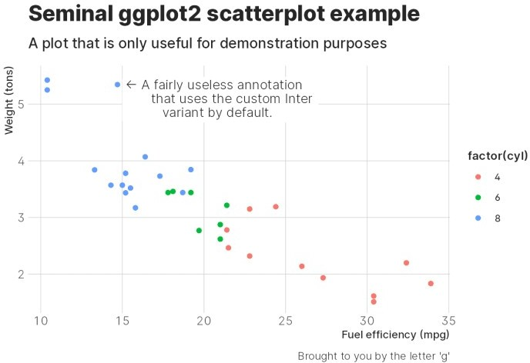

Wonderful kerning, a custom-built arrow due to fantastic, built-in ligatures, and spiffy tabular numbers. Gorgeous!

What was that you just asked? *What’s up with that mode = "light"?*. Did I forget to mention that all the {hrbragg} themes come with dark-mode support built in? My sincerest apologies.

Choosing mode = "dark" will use a (configuratble) dark theme and using mode = "rstudio" (if you’re an RStudio user) will have the charts take on the IDE theme setting automagically. Here’s dark mode:

gg1 + theme_inter(grid = "XY", mode = "dark")

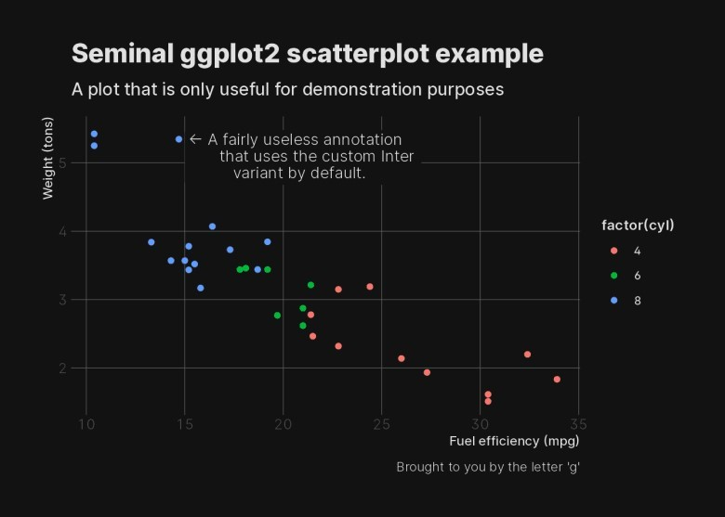

The font+theme pairs automatically work and reconfigure all the ggplot2 aesthetic defaults accordingly. Since this makes heavy use of update_geom_defaults() I’ve included a (very necessary) reset_ggplot2_defaults() to get things back to normal when you need to.

Note that you can use adaptive_color() to help enable dark/light-mode color switching for your own pairings, and theme_background_color() or theme_foreground_color to utilize the (reconfigurable) default fore- and background theme colors.

# Try before you buy…into using a given font

One can’t know ahead of time whether a font is going to work well, and you might want go get a feel for how a given set of family variants work for you. To that end, I’ve made it possible to preview any font you’ve reconfigured with reconfigure_font() via preview_variant(). It uses some pre-set text that exercises the key features I’ve outlined, but you can sub your own for them if you want to look at something in particular. Let’s give inter_pkg a complete look:

preview_variant(inter_pkg)

We can look at another one that we’ll create now (I did not realize this font had tabular numbers

until Thomas built all these wonderful toys to play with!):

reconfigure_font(

family = "Trattatello", width = "normal",

ligatures = "discretionary", calt = 1, tnum = 1, case = 1,

dlig = 1, kern = 1,

zero = 0, salt = 0

) -> trat

preview_variant(trat)

# FIN

The {hrbragg} package is not even 24 hours old yet, so there are breaking changes and many new, heh, *features* still to come, but please — as usual — kick the tyres and post questions, feedback, contributions, or suggestions wherever you’re most comfortable (the package is on most of the popular social coding sites).